Cyberlight Aurora Installation Instructions
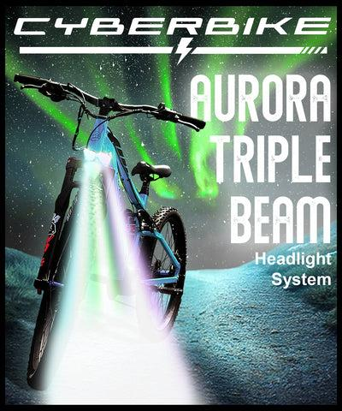
Read the entire instructions and complete this installation prior to using your Cyberblight product

1. Locate and remove the screw that is already fastened onto the rear of the fork brace:
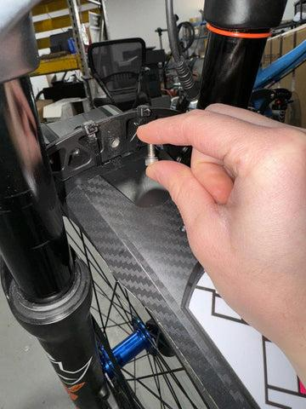
2. Mount the Aurora by threading the screw into the fork brace. Ensure that your Aurora is level before tigthening. We also suggest using Locktite or another thread selant to make sure all light hardware is secure. You are responsible for regularly checking all hardware and components on your bike for tightness, function, and wear. Refer to your owners manual for more.
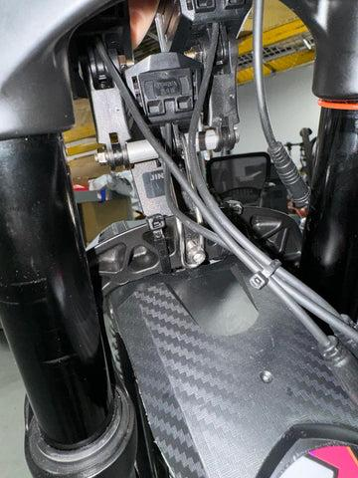
3.Route the cables between the forks and locate the red waterproof connector for the light coming from the bike housing. Unless you have modified your cable routing, this will likely be bundled with the other cables of the right side handlebar. Carefully line up the pins and arrows they are not highly visible. Failure to line up the connectors correctly may result in damage to your wiring harness or lighting connector. Such damage is not covered under your warranty, so pelase be careful.

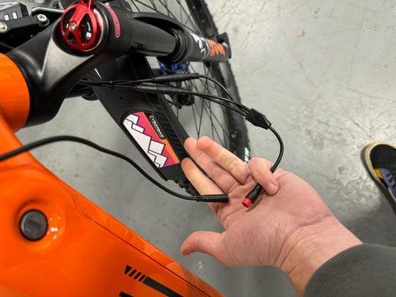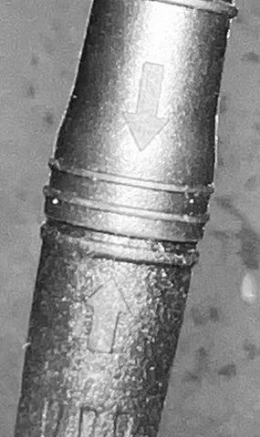
4. Clean up your cables by feeding the extra cable into the right side of the frame.
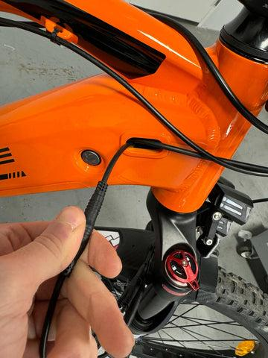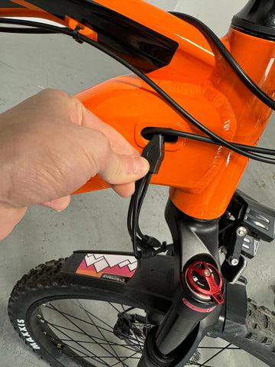
5. To turn the light on and off, hold the '+' sign on the left handlebar-mounted control pod for 2 seconds

When your Cyberlight is on, the lighting indicator will appear in the top left of your display screen (2024 model shown)
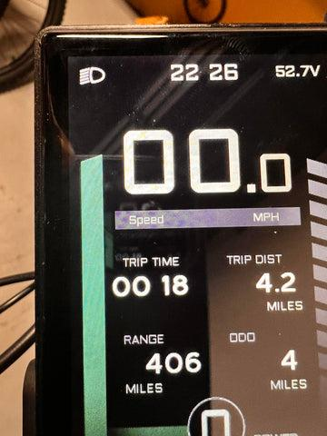
Aiming
Your Cyberlight Aurora offers a customizable multi-light system tailored to suit your riding style and the specific needs of your environment. For example, the speed of your ride influences how far ahead you'll want your beam to reach. Out of the box, your Cyberlight Aurora comes configured with two lights adjusted to illuminate the ground approximately 12-15 feet ahead, and a third light set to illuminate further into the distance. To customize this setup, you will need to re-tighten the lights' fixtures after adjusting their direction.
It's crucial when cycling near traffic to ensure your lights are not positioned in a way that could blind or distract oncoming traffic, including other cyclists. This is important to avoid creating hazardous situations.

